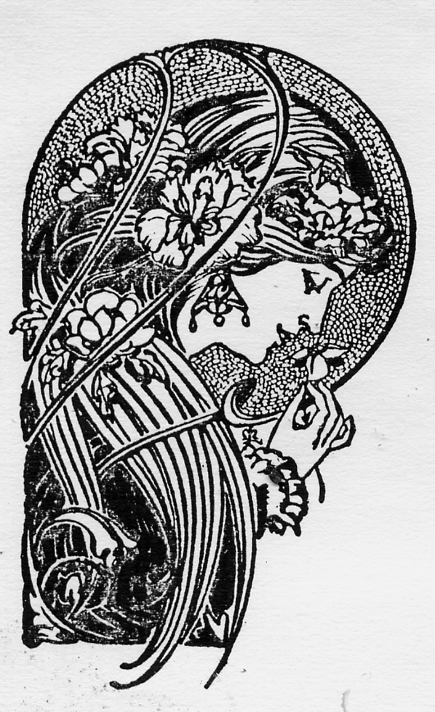

The Eclectic Muse
A Poetry Journal, Volume 14, Christmas 2008
Joe M. Ruggier, Managing Editor
307 Birchwood Court, 6311 Gilbert Road
Richmond, BC, CANADA V7C 3V7
TEL: (604) 277-3864

e-mail: jrmbooks@hotmail.com

“There are many Mansions in Parnassus!”

None of the poetry or prose in this Journal may be reproduced in any form whatsoever without the prior consent of the Publisher. All rights revert to the Authors. Would all contributors, please!!!, send immediately and promptly to the Managing Editor more submissions of your very best work? as well as urgently required subscription monies?? We are now compiling work for Volume 15, (Christmas 2009) …

Brief Submission Guidelines

- Never submit more than 5 poems for any one annual issue: our workload forbids it …
- You should send your submission by regular mail only if you have no access to a computer or you are computer illiterate
- you should always submit your document as an attachment to an email. This makes our work easier.
- the preferred format for submitting your document is Microsoft Word with a .doc extension or else as an RTF with a .rtf extension
- in view of our workload you must never submit poetry as an attachment to an email in the form of one separate document per poem. You should always submit your five poems as one long document produced in Word featuring all five poems in one document
- typeset everything in Times New Roman 12 point. Leave all other formatting to TEM
- unless your poetry features indents & special formatting you should produce every single line flushed left against the left margin
- if your poetry features indents & special line spacing please make sure you reproduce these features yourself in your data entry since it will not be possible for the editor to determine your intentions
- always send a very brief bio to the editor of a recommended length of not more than 100 words. The contents of your bio should briefly deal with: your name; your credentials (degrees etc); your occupation & marital status; your most major publication credits only; any hobbies, interests, activities for leisure that you indulge in.
- always send to TEM your clear email address; and also
- always send to TEM your extremely clear regular mailing address (snailmail) just so the editor can complete your section in the journal, featuring your name, hometown & state/province, as well as be able to mail you your author’s copy of the issue in which your work is featured.
- Thank you to all of you for being a part of The Eclectic Muse

To Our Readers
RE: Subscriptions and Rates

Dear Readers:

Subscription time is any time! TEM relies entirely on the support of University & Public Libraries and on sales to local & international subscribers such as you are. Without your generous and perceptive support there would be no TEM at all.

Our costs have gone up since the cost of paper inflates from month to month. An increase in the subscription rate is a very serious consideration. There are so many worthy causes and legitimate claims on your generosity that we are somewhat appalled to raise the cost of TEM. Given the unique nature of this publication we hope that you will not be shocked at the subscription of $25/volume & $8/ sample copy. We hope that the current appearance of TEM once yearly only instead of once every four months will give you time to breathe, to catch up on your reading commitments and to count your money carefully.

Another issue presents itself. Please understand that TEM is a non-profit venture. The business charges which we would have to pay to operate a proper business account would sink us. For this reason it is required that you make all your checks/money-orders payable to Joe Ruggier rather than to the corporate name.

Please send a photocopy of this subscription form along with a check or money order, made payable to Joe Ruggier, to the address below.

Mr. Joe M. Ruggier, Managing Editor
The Eclectic Muse, 307 - 6311 Gilbert Road
Richmond, BC, CANADA V7C 3V7
Ph: (604) 277-3864
e-mail: jrmbooks@hotmail.com

Enclosed is __________ for a __________ {No of Volumes} subscription to TEM. Enclosed is __________ for __________ {No of sample copies}. Sample copies of the magazine are $8 each {$US8 -- USA; £4 stg -- UK}. One year’s subscription to TEM is $25 {$US25 -- USA; 13 pounds sterling in Britain}.

Name: ______________________________________________
Address: ______________________________________________
______________________________________________________
______________________________________________________

We hope that you will help support deserving authors everywhere by purchasing a subscription. We cordially invite you to subscribe to TEM. Thank you.

The Editor

All Contributors please enclose a 50-100 word bio to be used at the discretion of the Editor. Poetry books to be reviewed in TEM should be sent c/o the Managing Editor. Authors contributing work to TEM may be required to submit to Editorial comment unless they advise otherwise in writing. TEM is not liable for the safety of unsolicited MSS.

All Editorial Statements contained in TEM are the opinions of the Managing Editor & not necessarily of any Associate, Guest, or Contributing Editor. All opinions expressed in the signed articles within TEM are likewise those of their respective Authors & not necessarily of TEM or of its individual Editors & Contributors.

All Female Authors, whether published in TEM or not, please note that TEM is not a feminist magazine; notwithstanding which it is the firm policy of the Publisher to publish both men & women writers equally.

All Authors who would like the Managing Editor to send them a careful, written examination of their writing together with materials for further reading ... please submit one of your best full-length manuscripts to the Managing Editor together with a reading, materials and assessment fee of $US 250. As long as your fee is enclosed the Editor shall write to you within eight (8) weeks.

Subscription Rates:
Full Year (One Volume): $25 (Canada)
$US 25 (USA)
£13 stg. (UK)
Sample Copies: $8 (USA/CANADA/UK)

Advertising Rates: 1 Page $120
half page $60
bzns card $25

Managing Editor ……………..........................................Joe M. Ruggier
Assistant Editor…….......................................................Basil Joseph Nainan
Desk-Top Publishing ………...........................................Joe M. Ruggier
Produced By ............................. Laser Graphics Ltd
253 East 11th Ave
Vancouver, BC
Tel: (604) 872-3231
The Eclectic Muse is published by ......................……...Multicultural Books
(MBooks of BC, Canada)

The Eclectic Muse 2008 ISSN 1181-8158
Volume 14, Christmas 2008 Legal Deposit Receipt No
With The National Library of Canada
411321

